|  |  |
| --- | --- |
|  |  |
| University of JeddahCollege of Computer Science and EngineeringDepartment of Software EngineeringCCSW321 – WEB DEVELOPMENT |  |
|  |  |
|  | **Assignment #1:****Creating a Personal Online Resume** |
|  | Maram Abdulrahman Alshahrani2210311 |

My website contains one page :

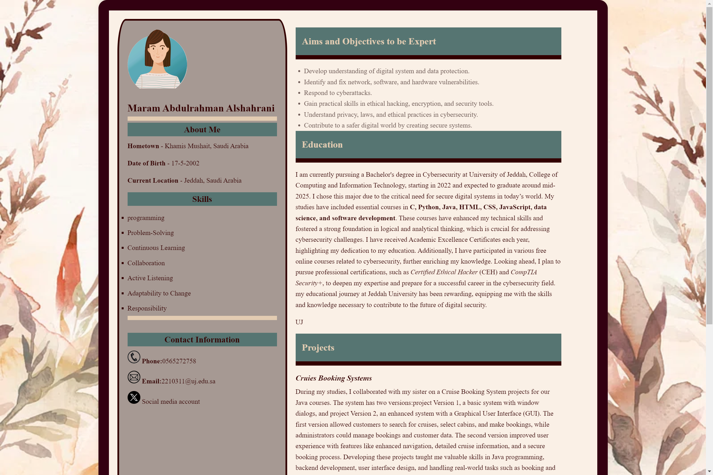

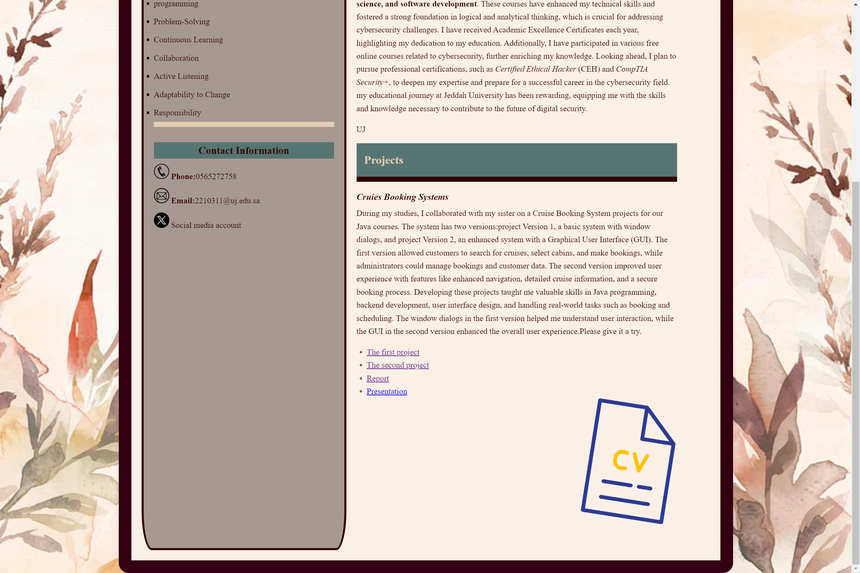

The html code :

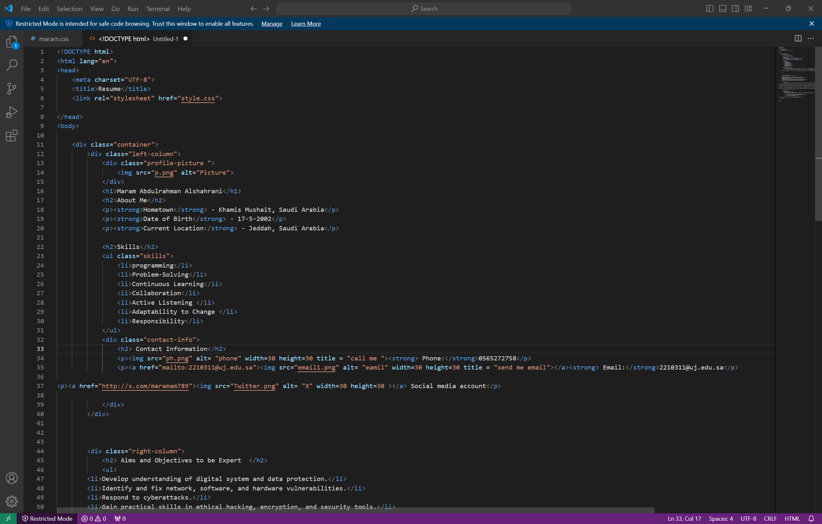

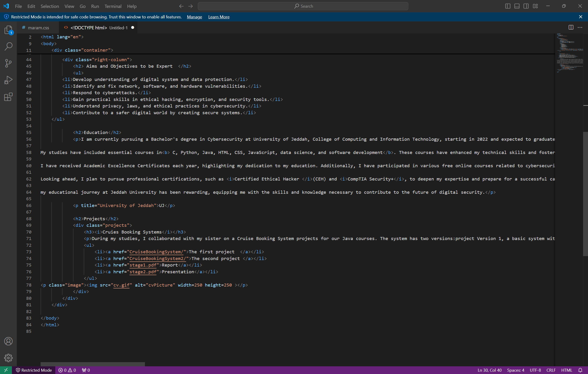

The css code :

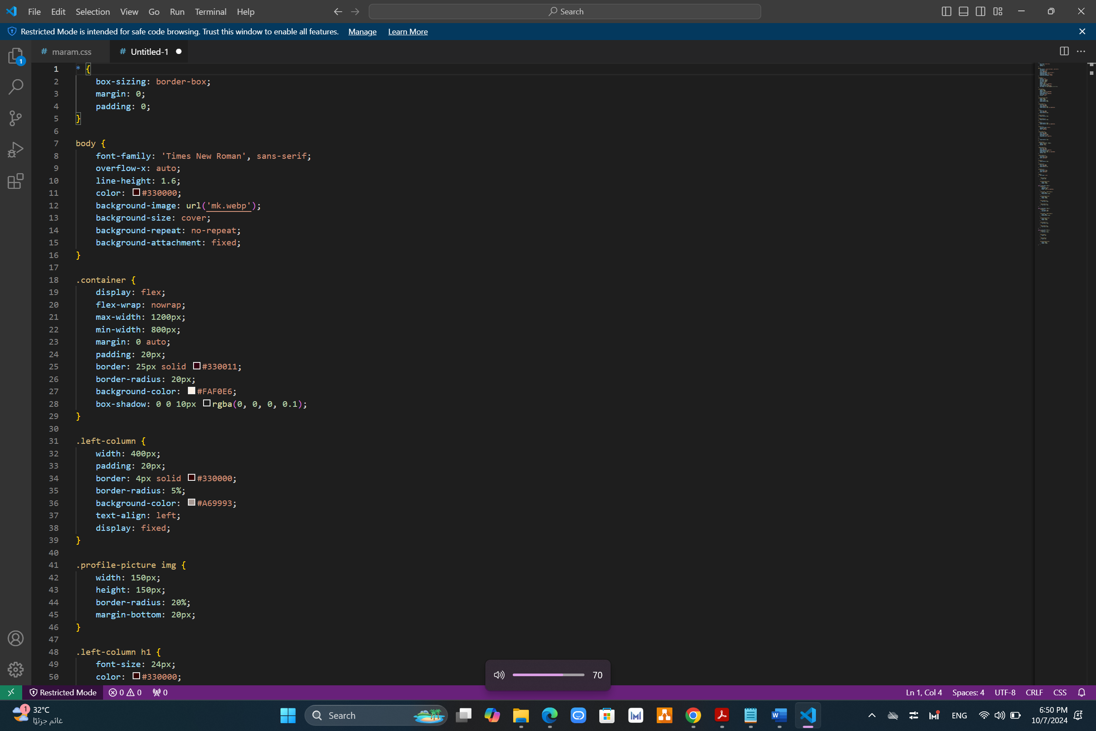

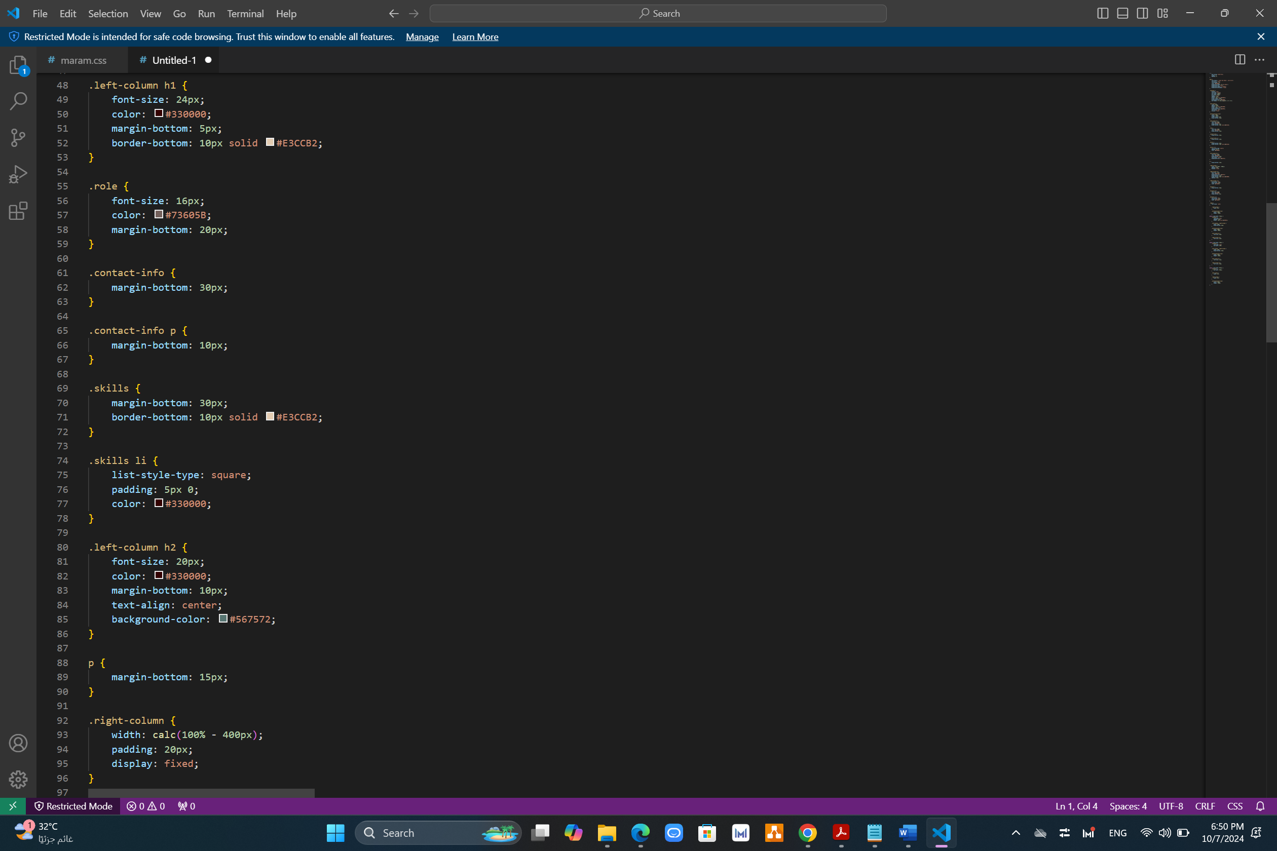

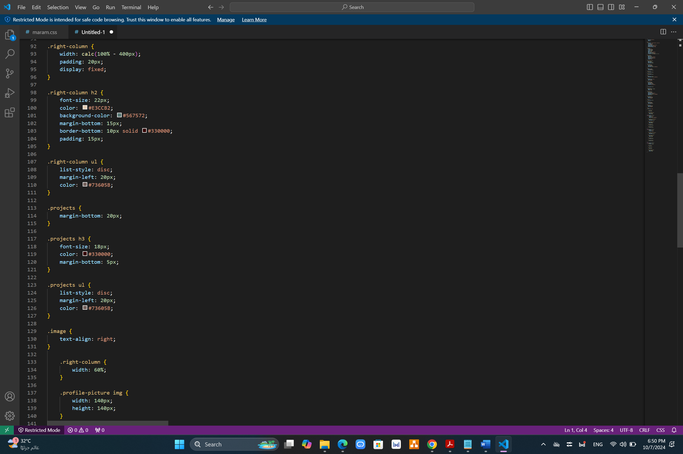

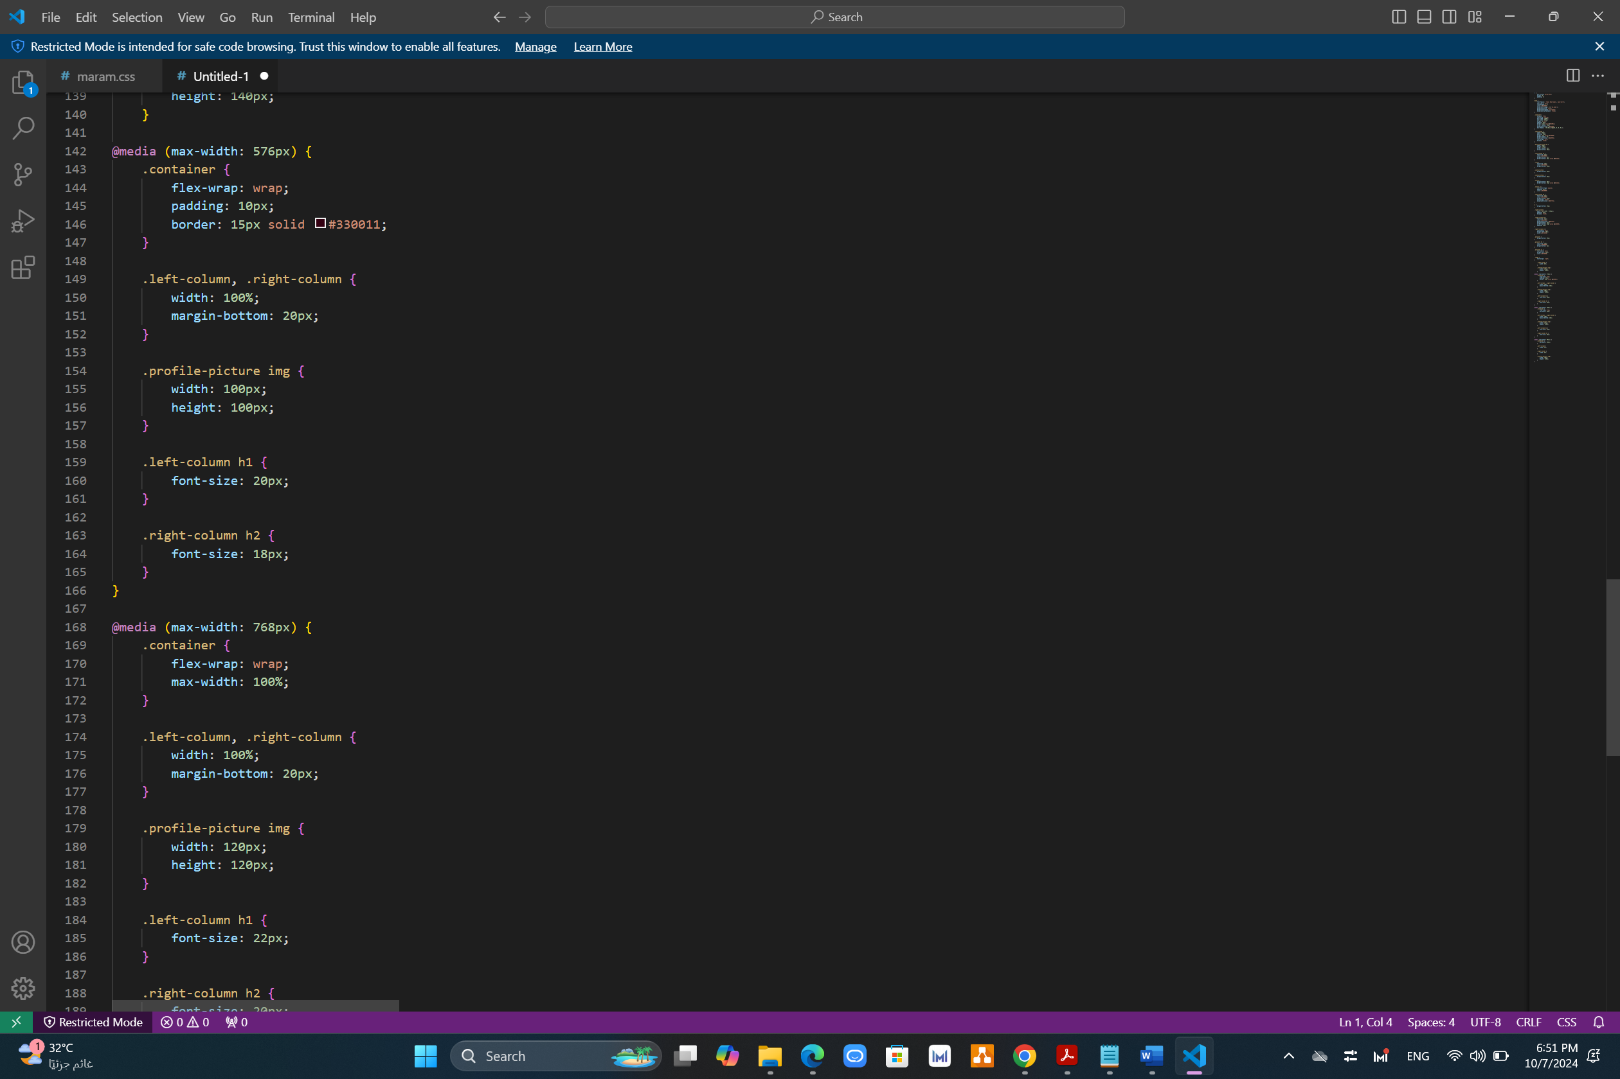

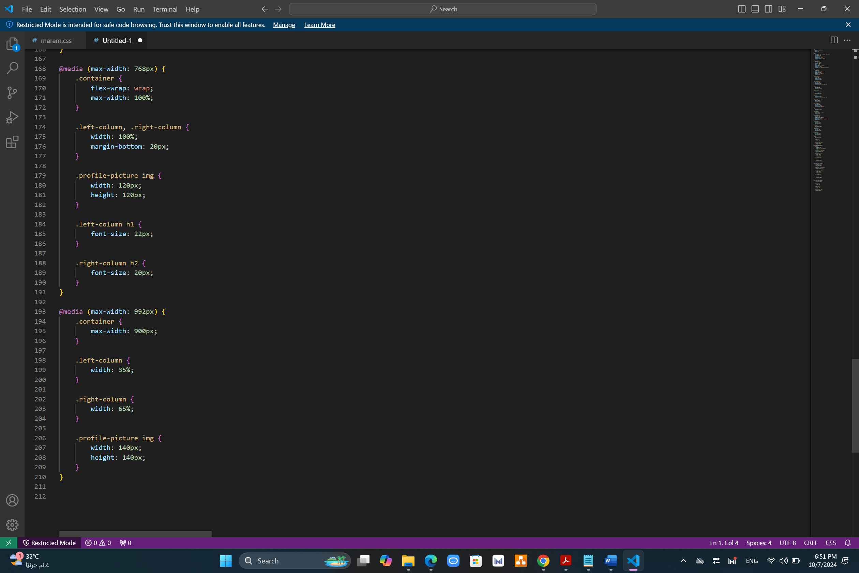

Validation :

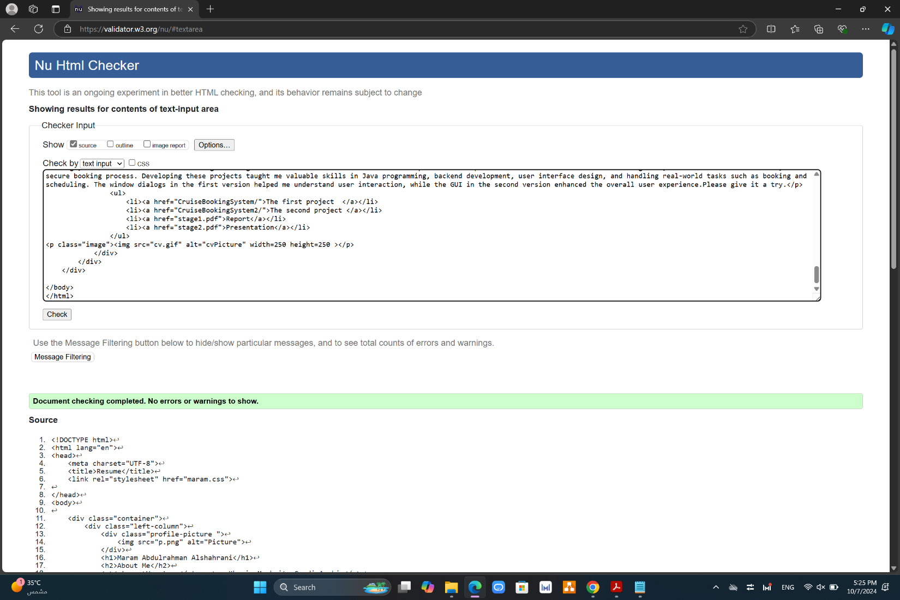

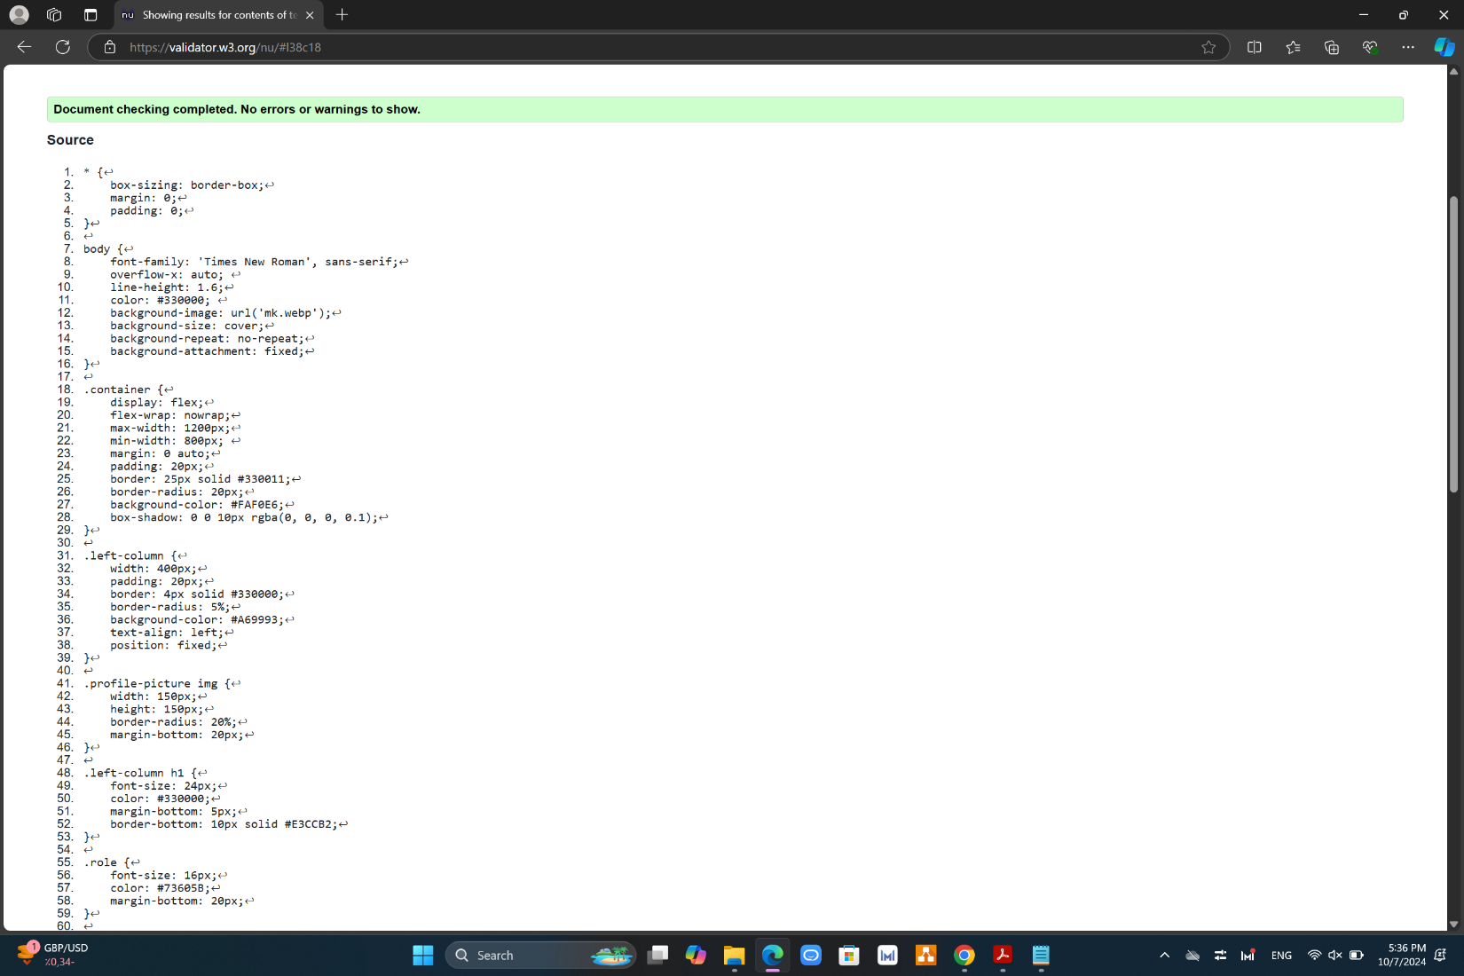

The screen shots displaying how the website is viewed on different

browser sizes

375px:

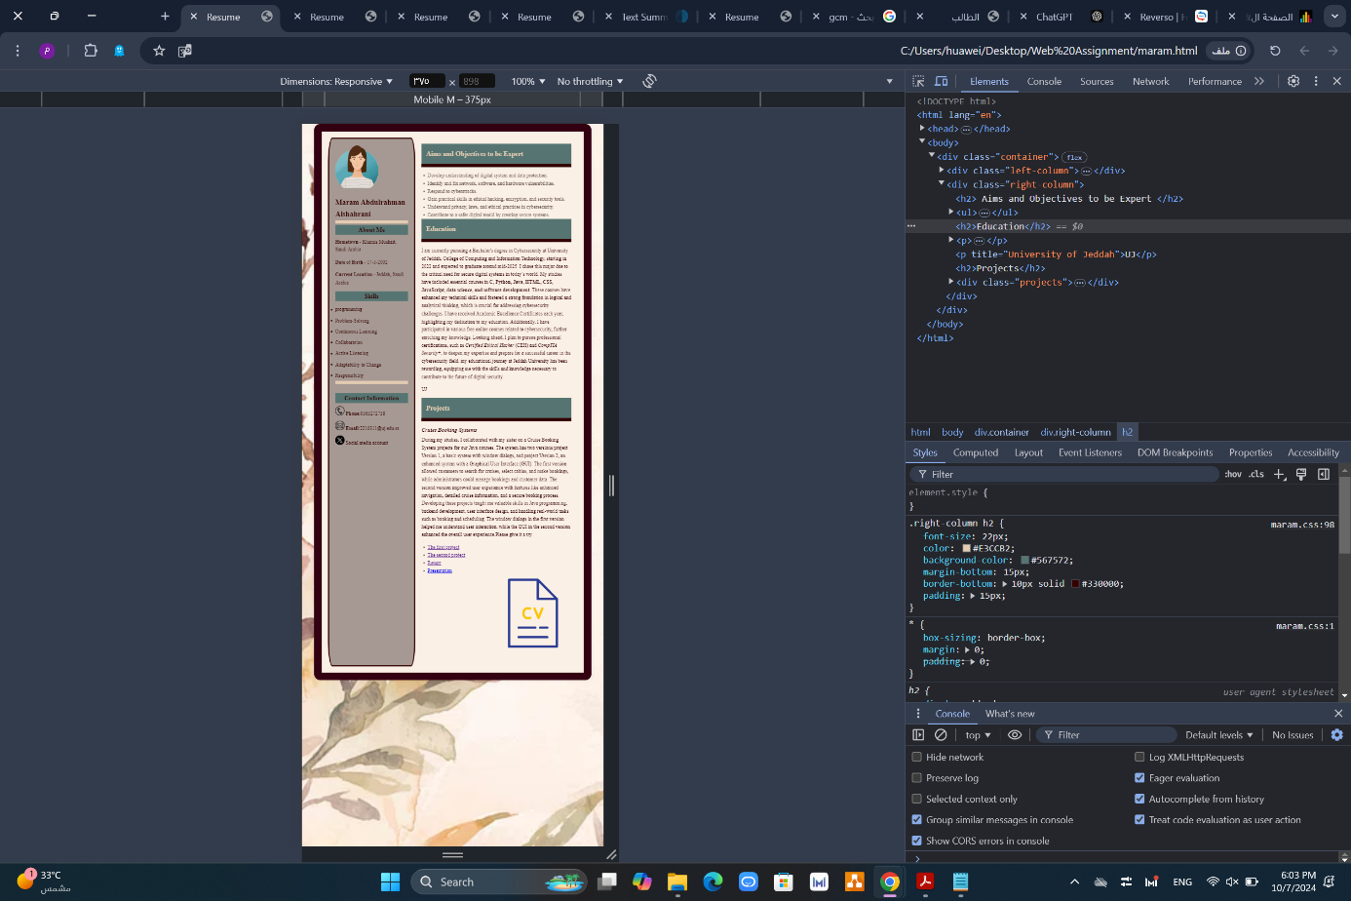

768px:

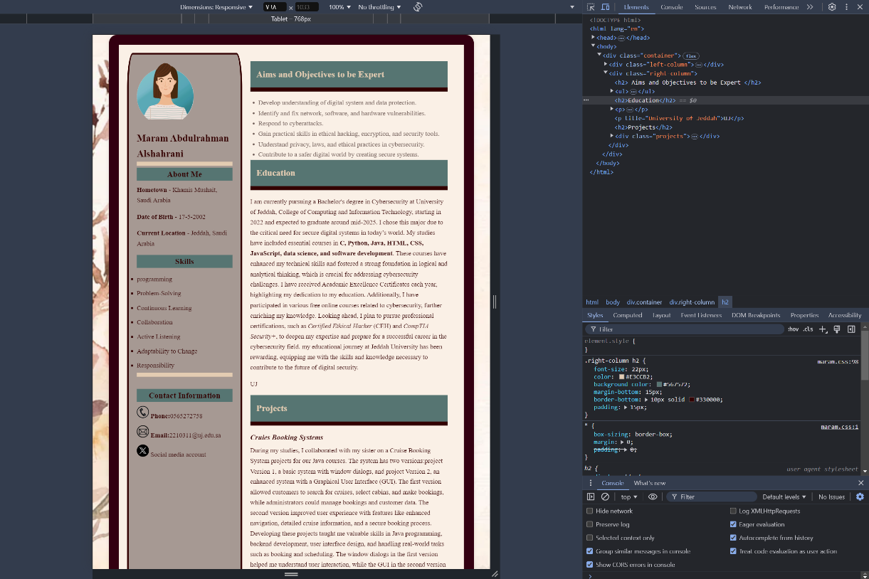

1200px:

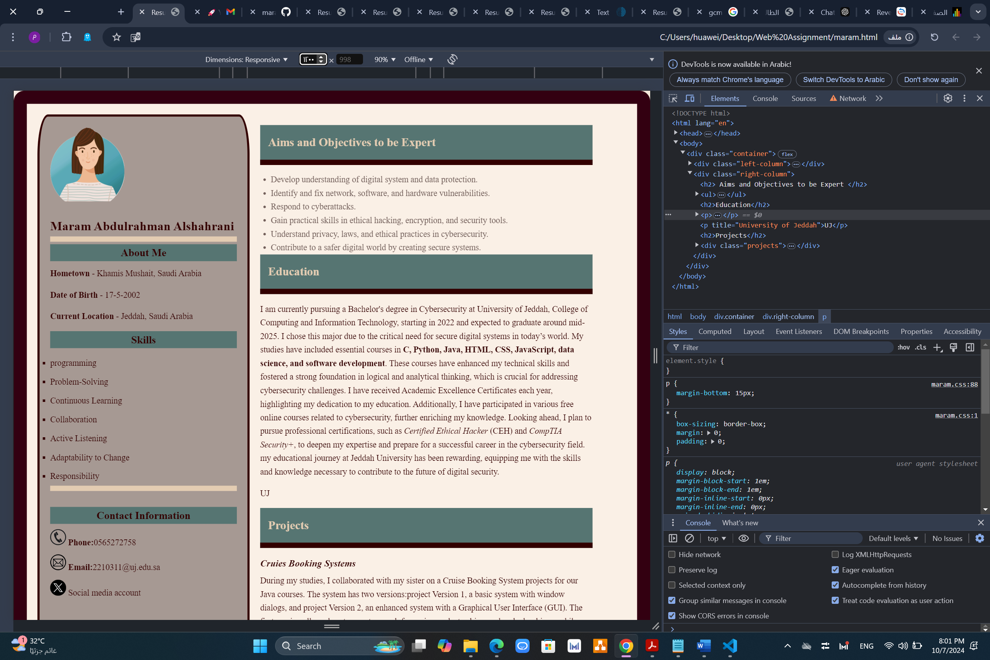

I was uploaded to GitHub

<https://github.com/maram2404/webAssignment.git>

<https://codespaces.new/maram2404/webAssignment>

